Assignment #3

Task #1:

Code:

#include<iostream>

#include<cstdlib>

#include<time.h>

using namespace std;

int main()

{

srand(time(0));

int dice1=0, dice2=0,num,sum=-1,count=0; /\*Here we are intiliazeing some variables \*/

cout << "Enter the Number : "; /\*Here we are Taking Input\*/

cin >> num;

cout << "\n";

while (num != sum) /\*when the both variables will same then the Looop will Terminate \*/

{

dice1 = rand() % 6 + 1; /\*These two Lines will Generate Random Number \*/

dice2 = rand() % 6 + 1;

sum = dice1 + dice2;

cout << sum << " "; //Displaying Sum //

count++;

}

cout << "The Number of Turns : " << count;

cout << endl;

system("pause");

return 0;

}

Output:

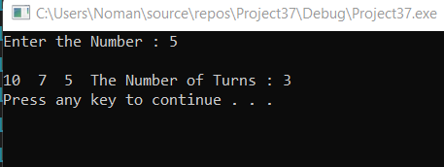

Question #2

Code:

#include<iostream>

using namespace std;

int main()

{

int arr[7];

cout << "Enter the elements of the array :"; /\*Here we are taking Input\*/

for (int i = 0; i < 7; i++) /\*This for Loop willl Take input \*/

{

cin >> arr[i];

}

int largest = 0;

for (int i = 0; i < 7; i++) /\*This For Loop is for finding the Largest NUmber in the array \*/

{

if (arr[i] > largest) /\*This is the condition for the largest Number \*/

{

largest = arr[i];

}

}

cout << "The Largest is : " << largest << endl; /\* Here we are displaying Largest Number \*/

int smallest = arr[0];

for (int i = 0; i < 7; i++) /\*This for loop is for smallest Number in the arry \*/

{

if (arr[i] < smallest) /\*This condition is for smallest element in the array \*/

{

smallest = arr[i];

}

}

cout << "The smallest is : " << smallest << endl; /\*Displaying Smallest Number \*/

system("pause");

return 0;

}

Output:

